**Project 3 Python**

Emilia Pawłowska s188854

**3/5 points**

**1.At the beginning  the program (in the console and in the frame) we have information about the author and title of the project. The player must enter the appropriate dimensions of the board in the console. The board cannot me smaller than m*n. In the console we have also information about colors. For the interface I used pygame.**

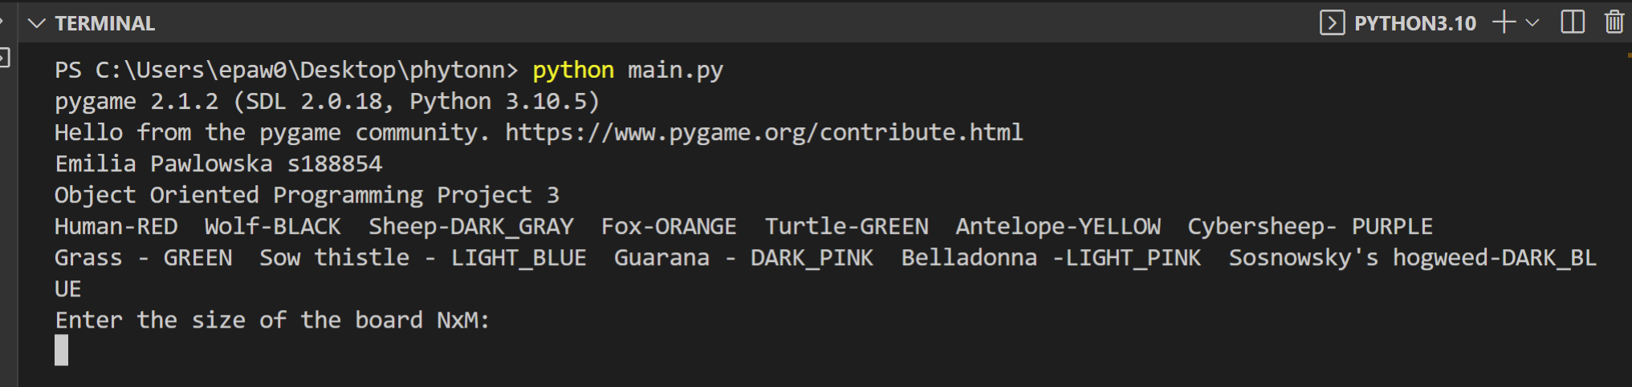

**2. After entering the numbers, the frame will be displayed. Organisms are placed randomly.** **The example below will show how to save the game. All we need to do is click the Save button. As a result the state of the world will be saved in the file “wynik.txt”(presented below).**

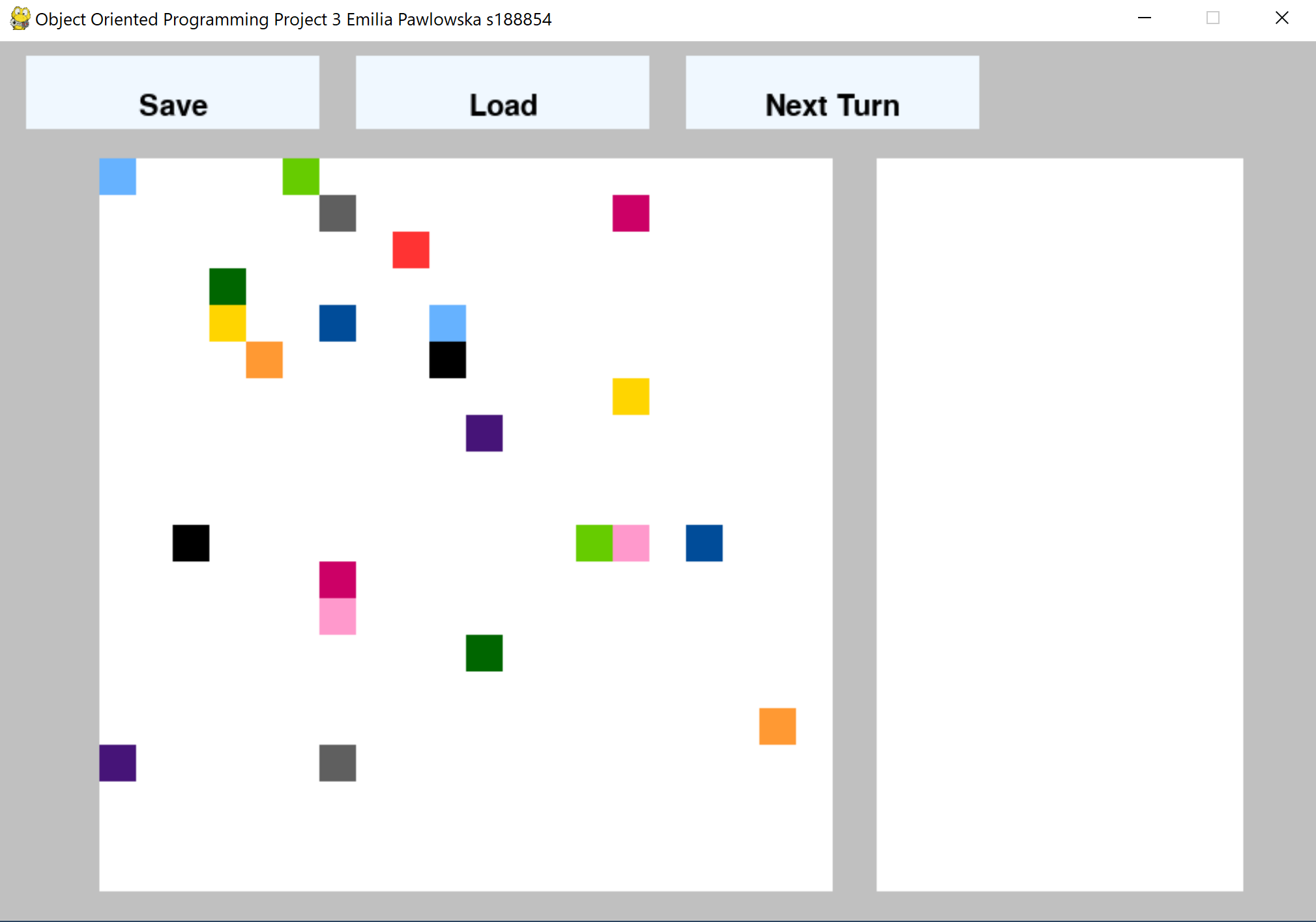

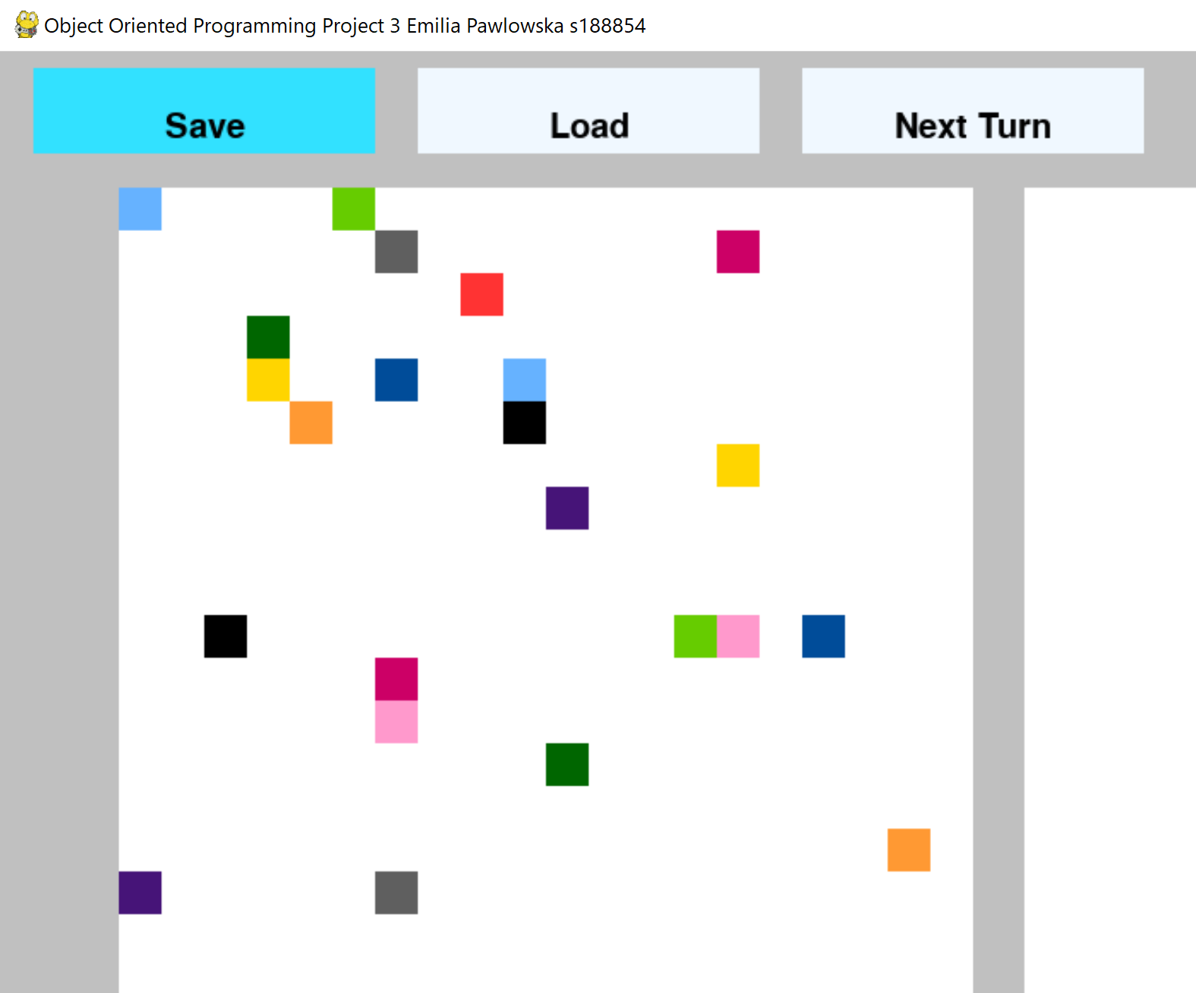

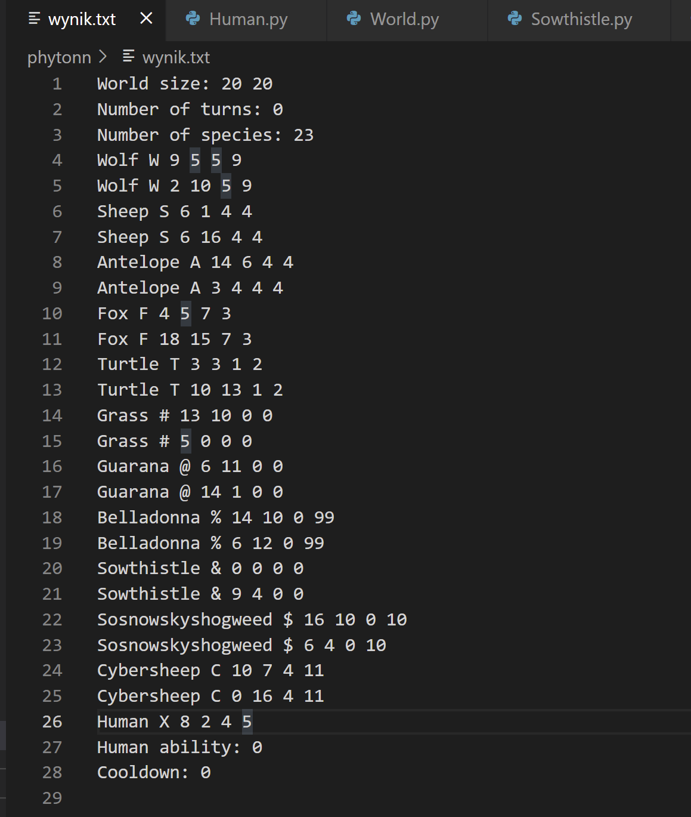

**3. Apart from saving we have also two other options: loading a world and going to the next round.** **If we click on the "Next turn" button, the board will change and we will see information about organisms on the right white panel. We move a human with arrows on keyboard. Below we have an example of a game.**

* **We can see: Antelope’s movement(2 cells), turtle’s 25% chance for moving, ability of Sosnowsky to kill Antelope from the distance.** 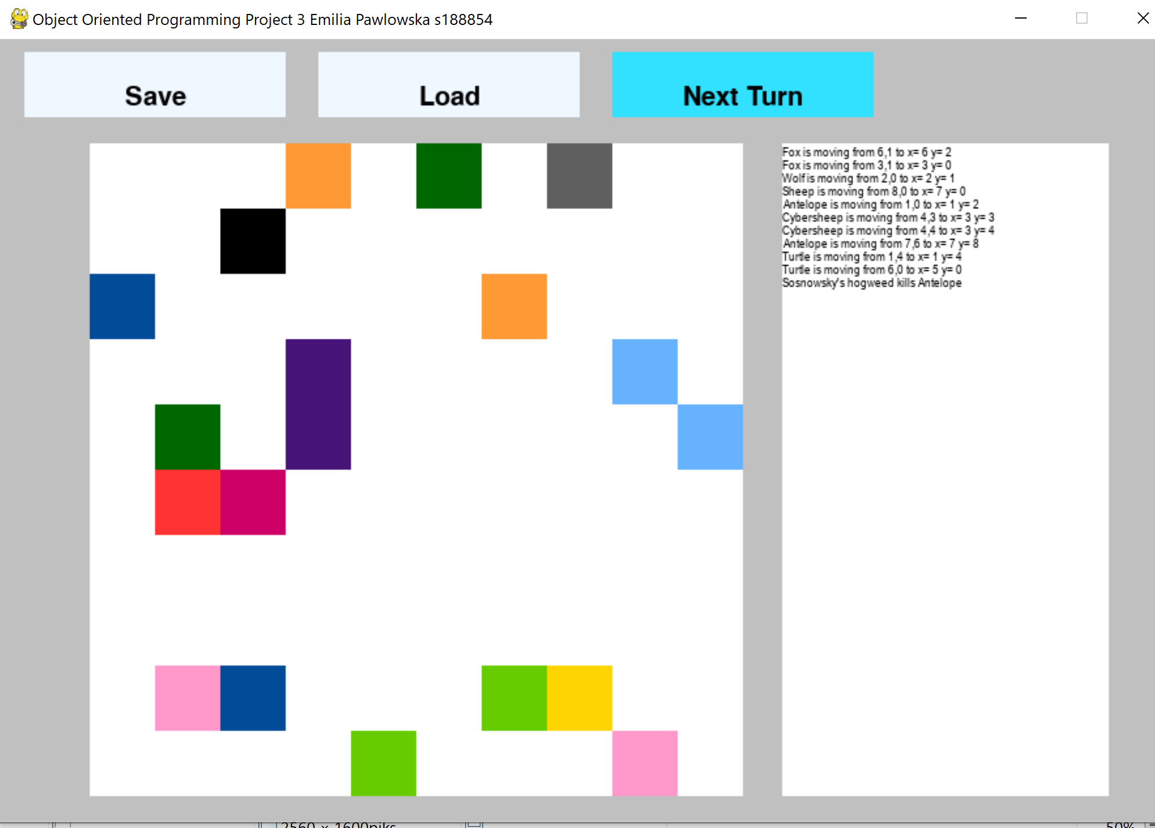
* **Few turns later we can see sowing of plants and ability of Guarana.**

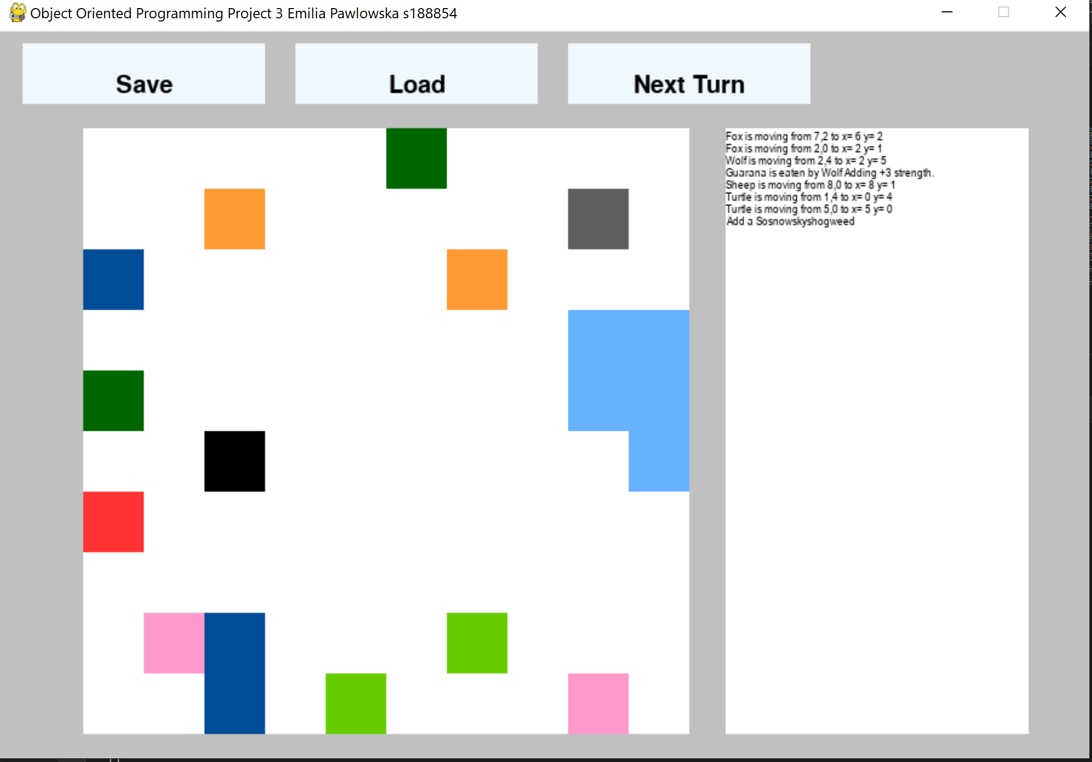

* **The game ends when the human dies.**



* **Another example:**

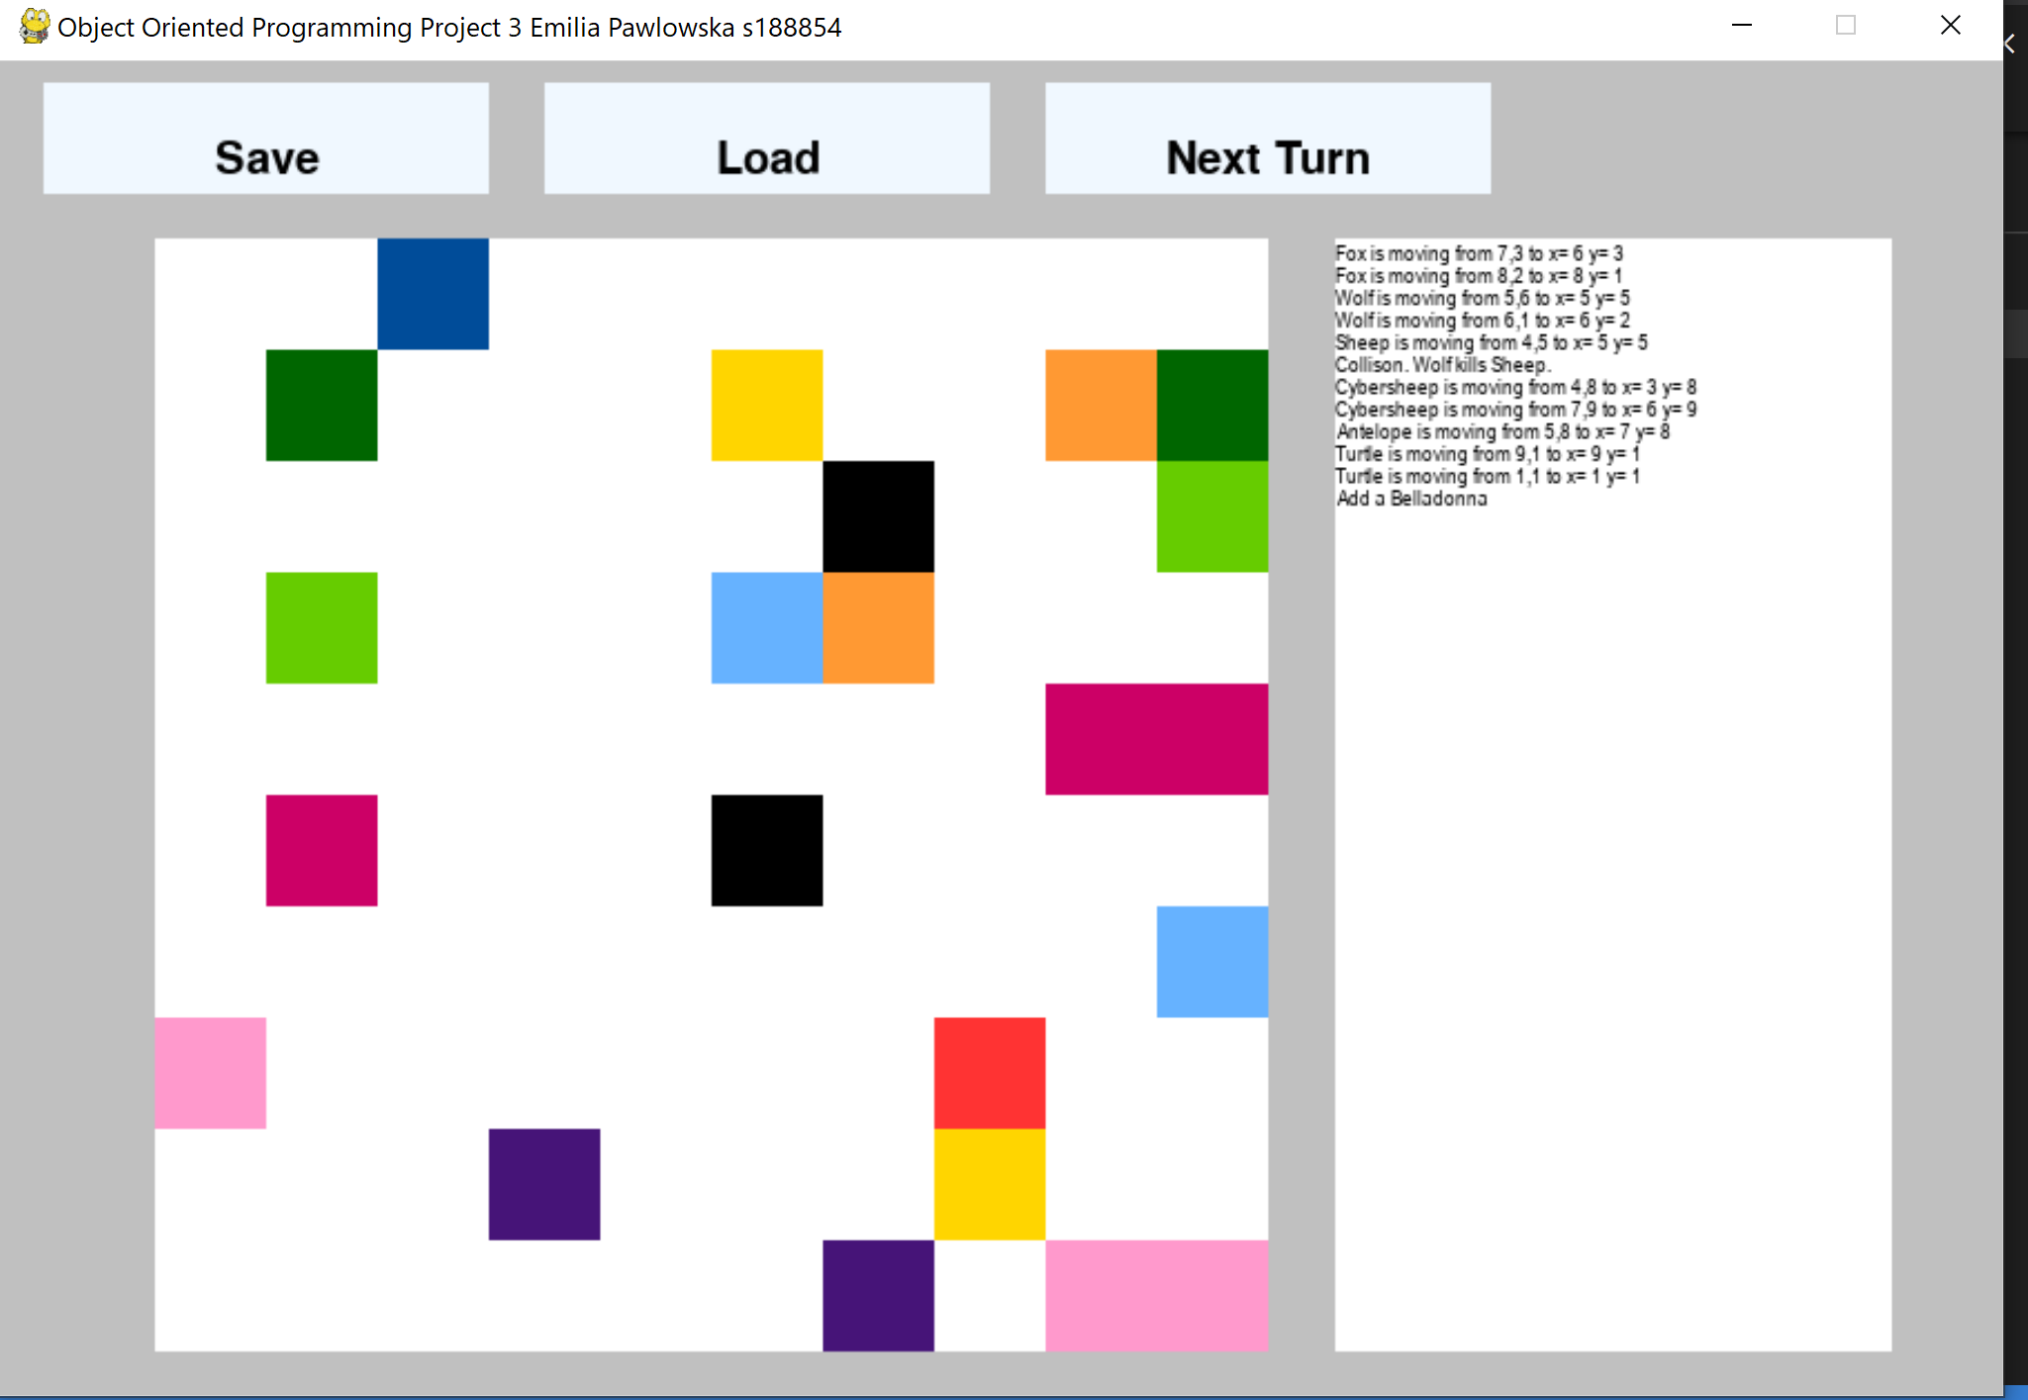

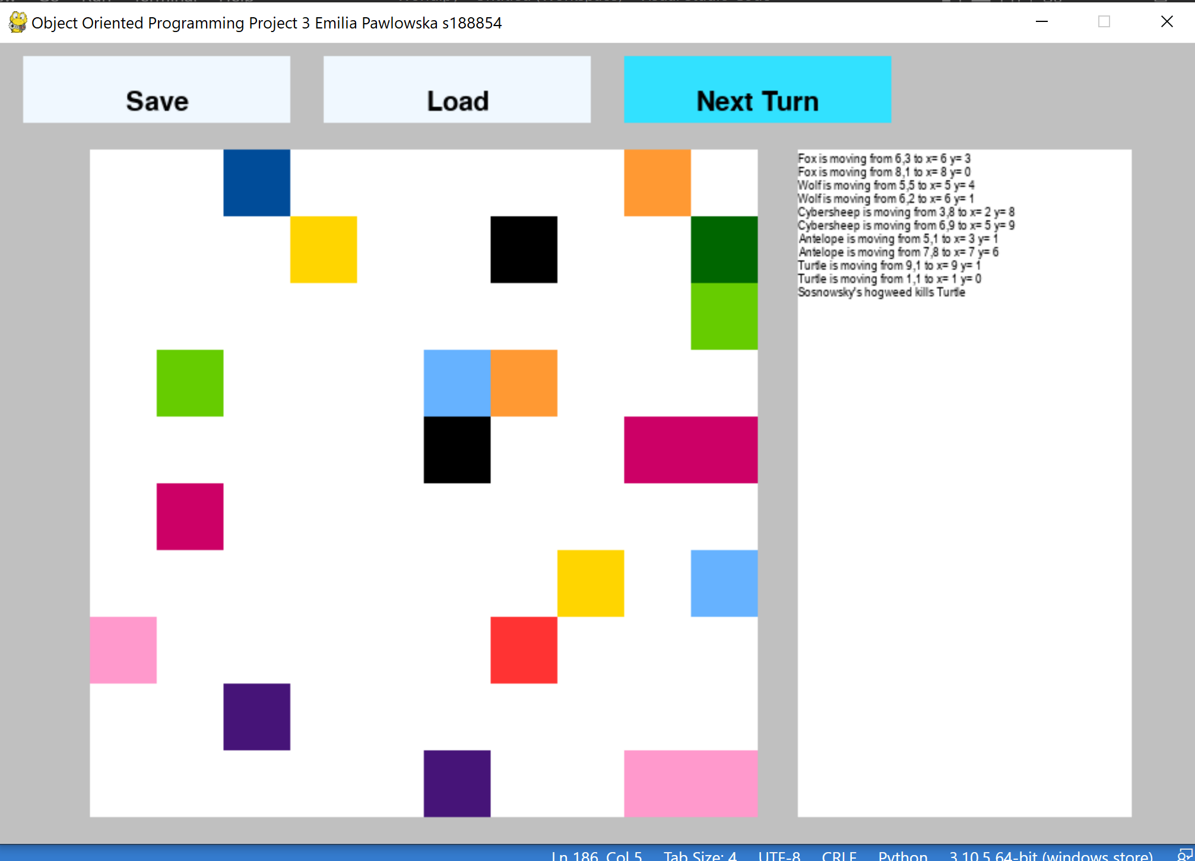

**4. We can load world from the file using the Load button.**

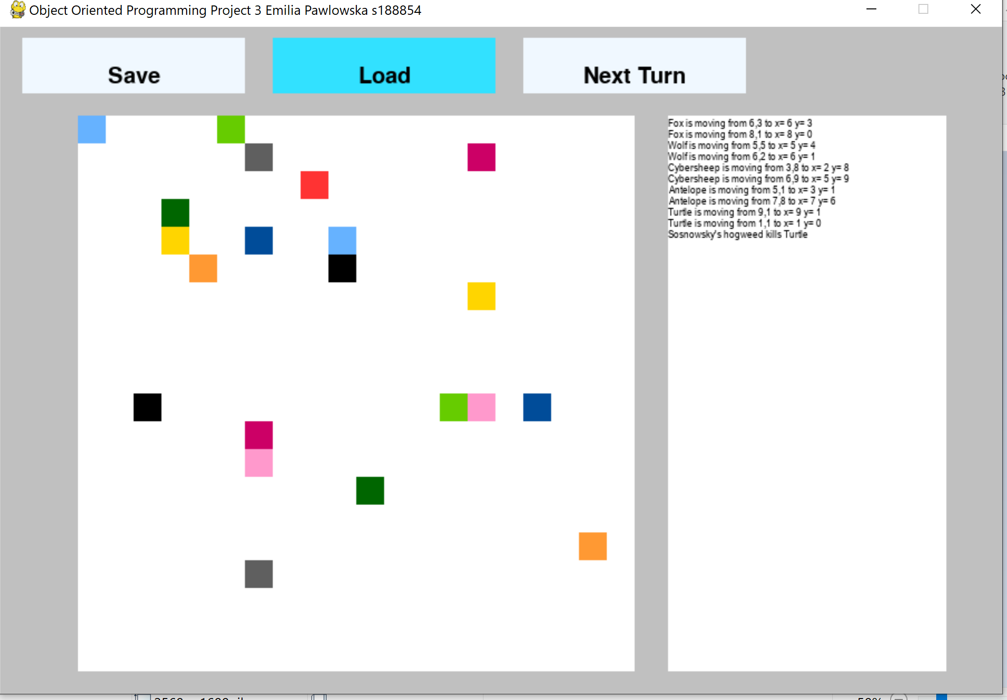

**5. A human's special skill is purification. We can turn it on by clicking "8" on the keyboard. It will last 5 rounds, and for the next 5 we will not be able to use it.**

**1. Information “Special ability on” on the left panel.**

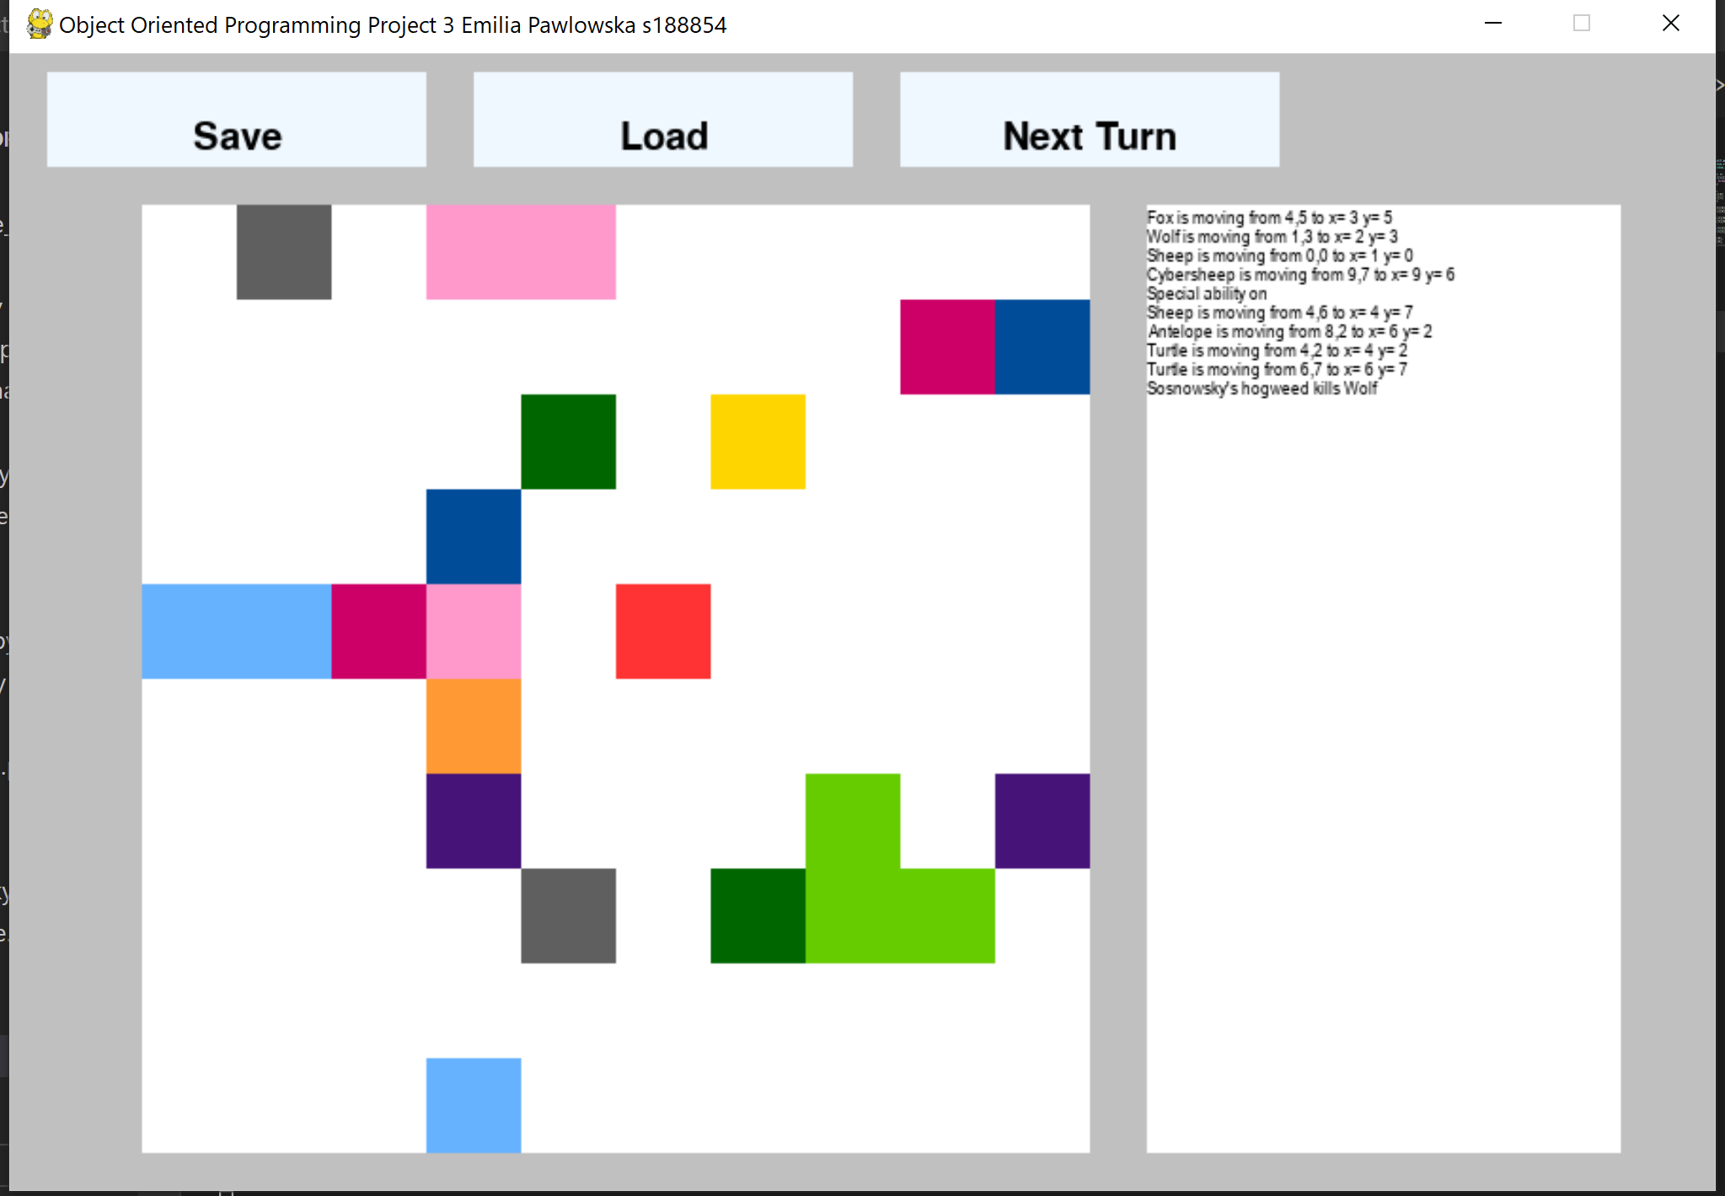

**2. Death of the Belladonna(light pink square).**



**6. In the project we had to create an extra organism-Cyber sheep. Below I present an example of its actions and the code. PURPLE=CYBERSHEEP BLUE=SOSNOWSKY**

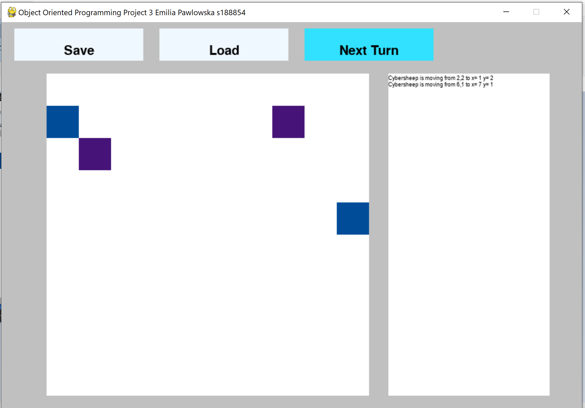

**Sheeps will go to the nearest Sosnowsky(the left one -west and the right one - south-east).**

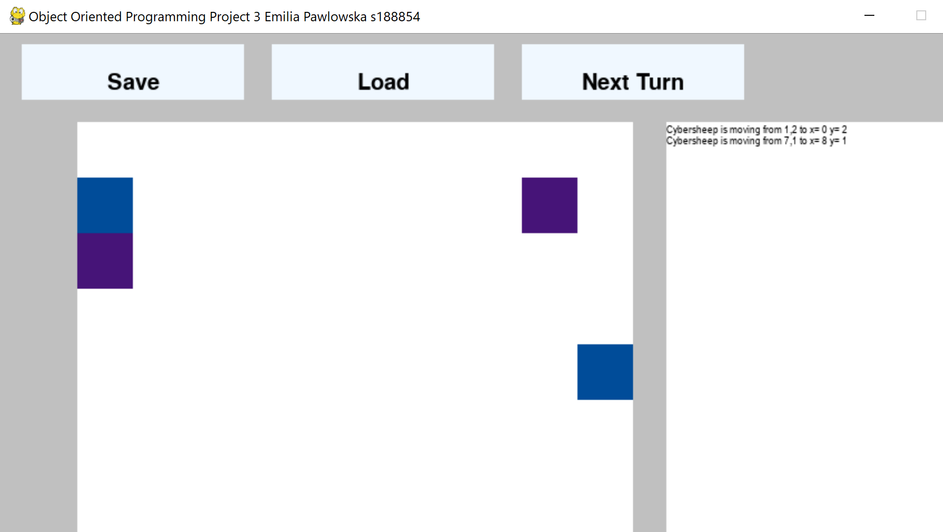

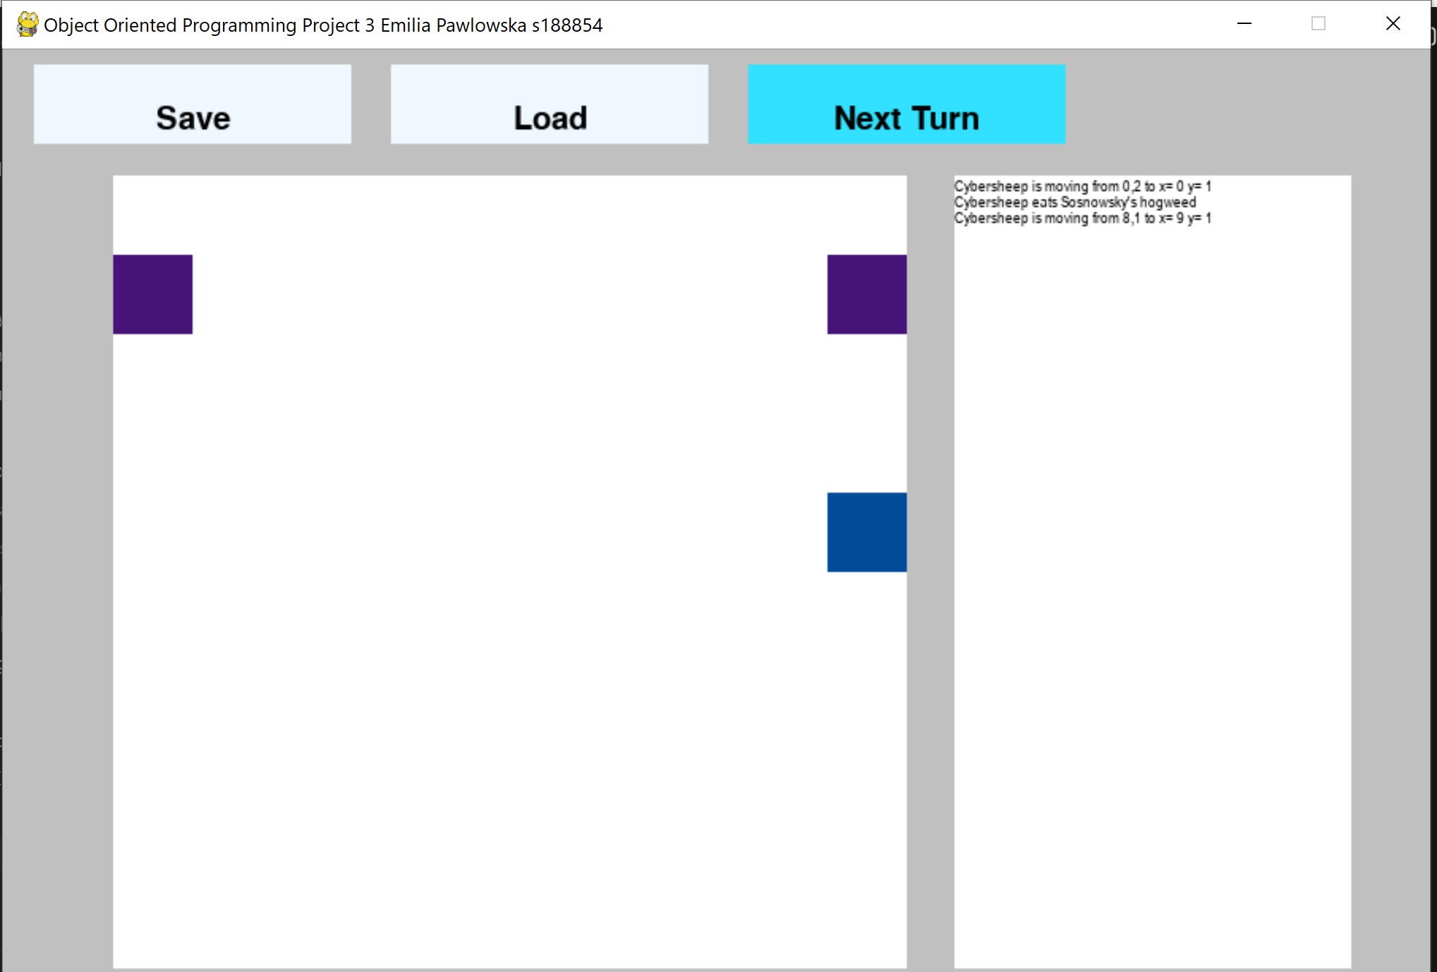

**After the kill the left sheep will be heading to the second Sosnowsky.**

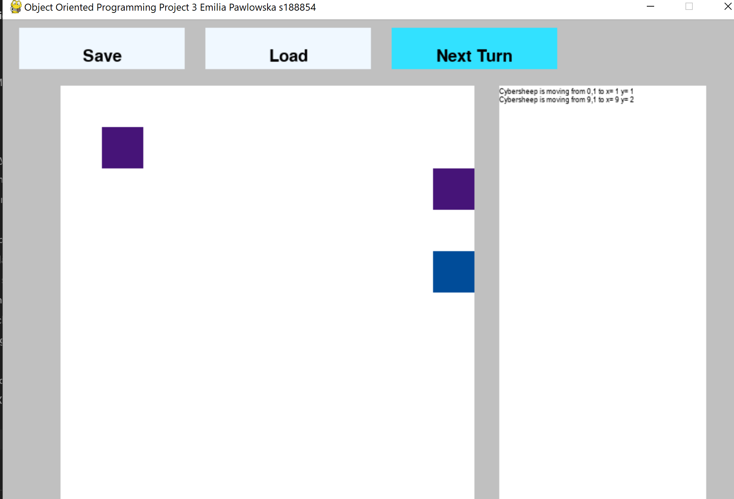

**The code:**

**We checked if there is any Sosnowsky on the map: if not- cybersheep behave like normal one, if yes – we calculate the distance(using math.hypot), then we sort the array and checked if the given Sosnowsky’s coordinate x is smaller or bigger than cybersheep’s. And the same with y.**

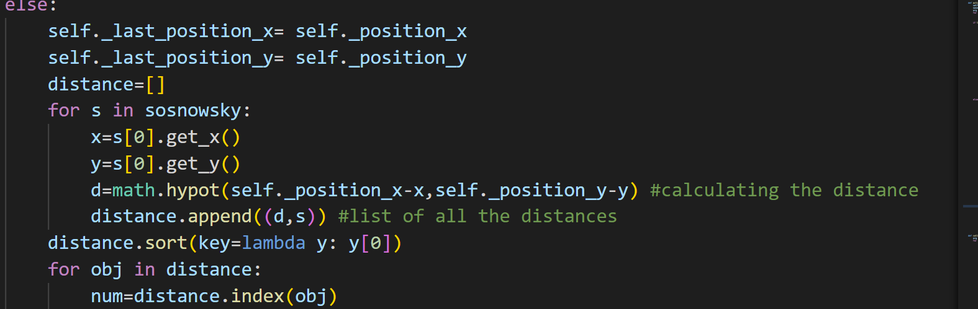

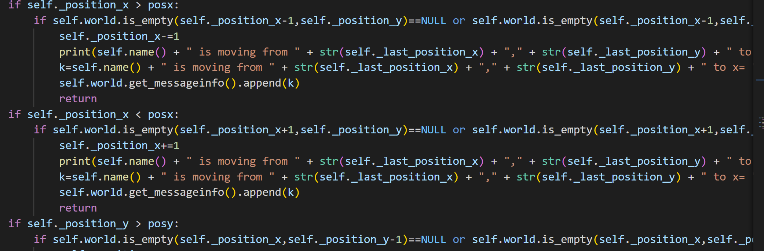

**Interface in pygame:**

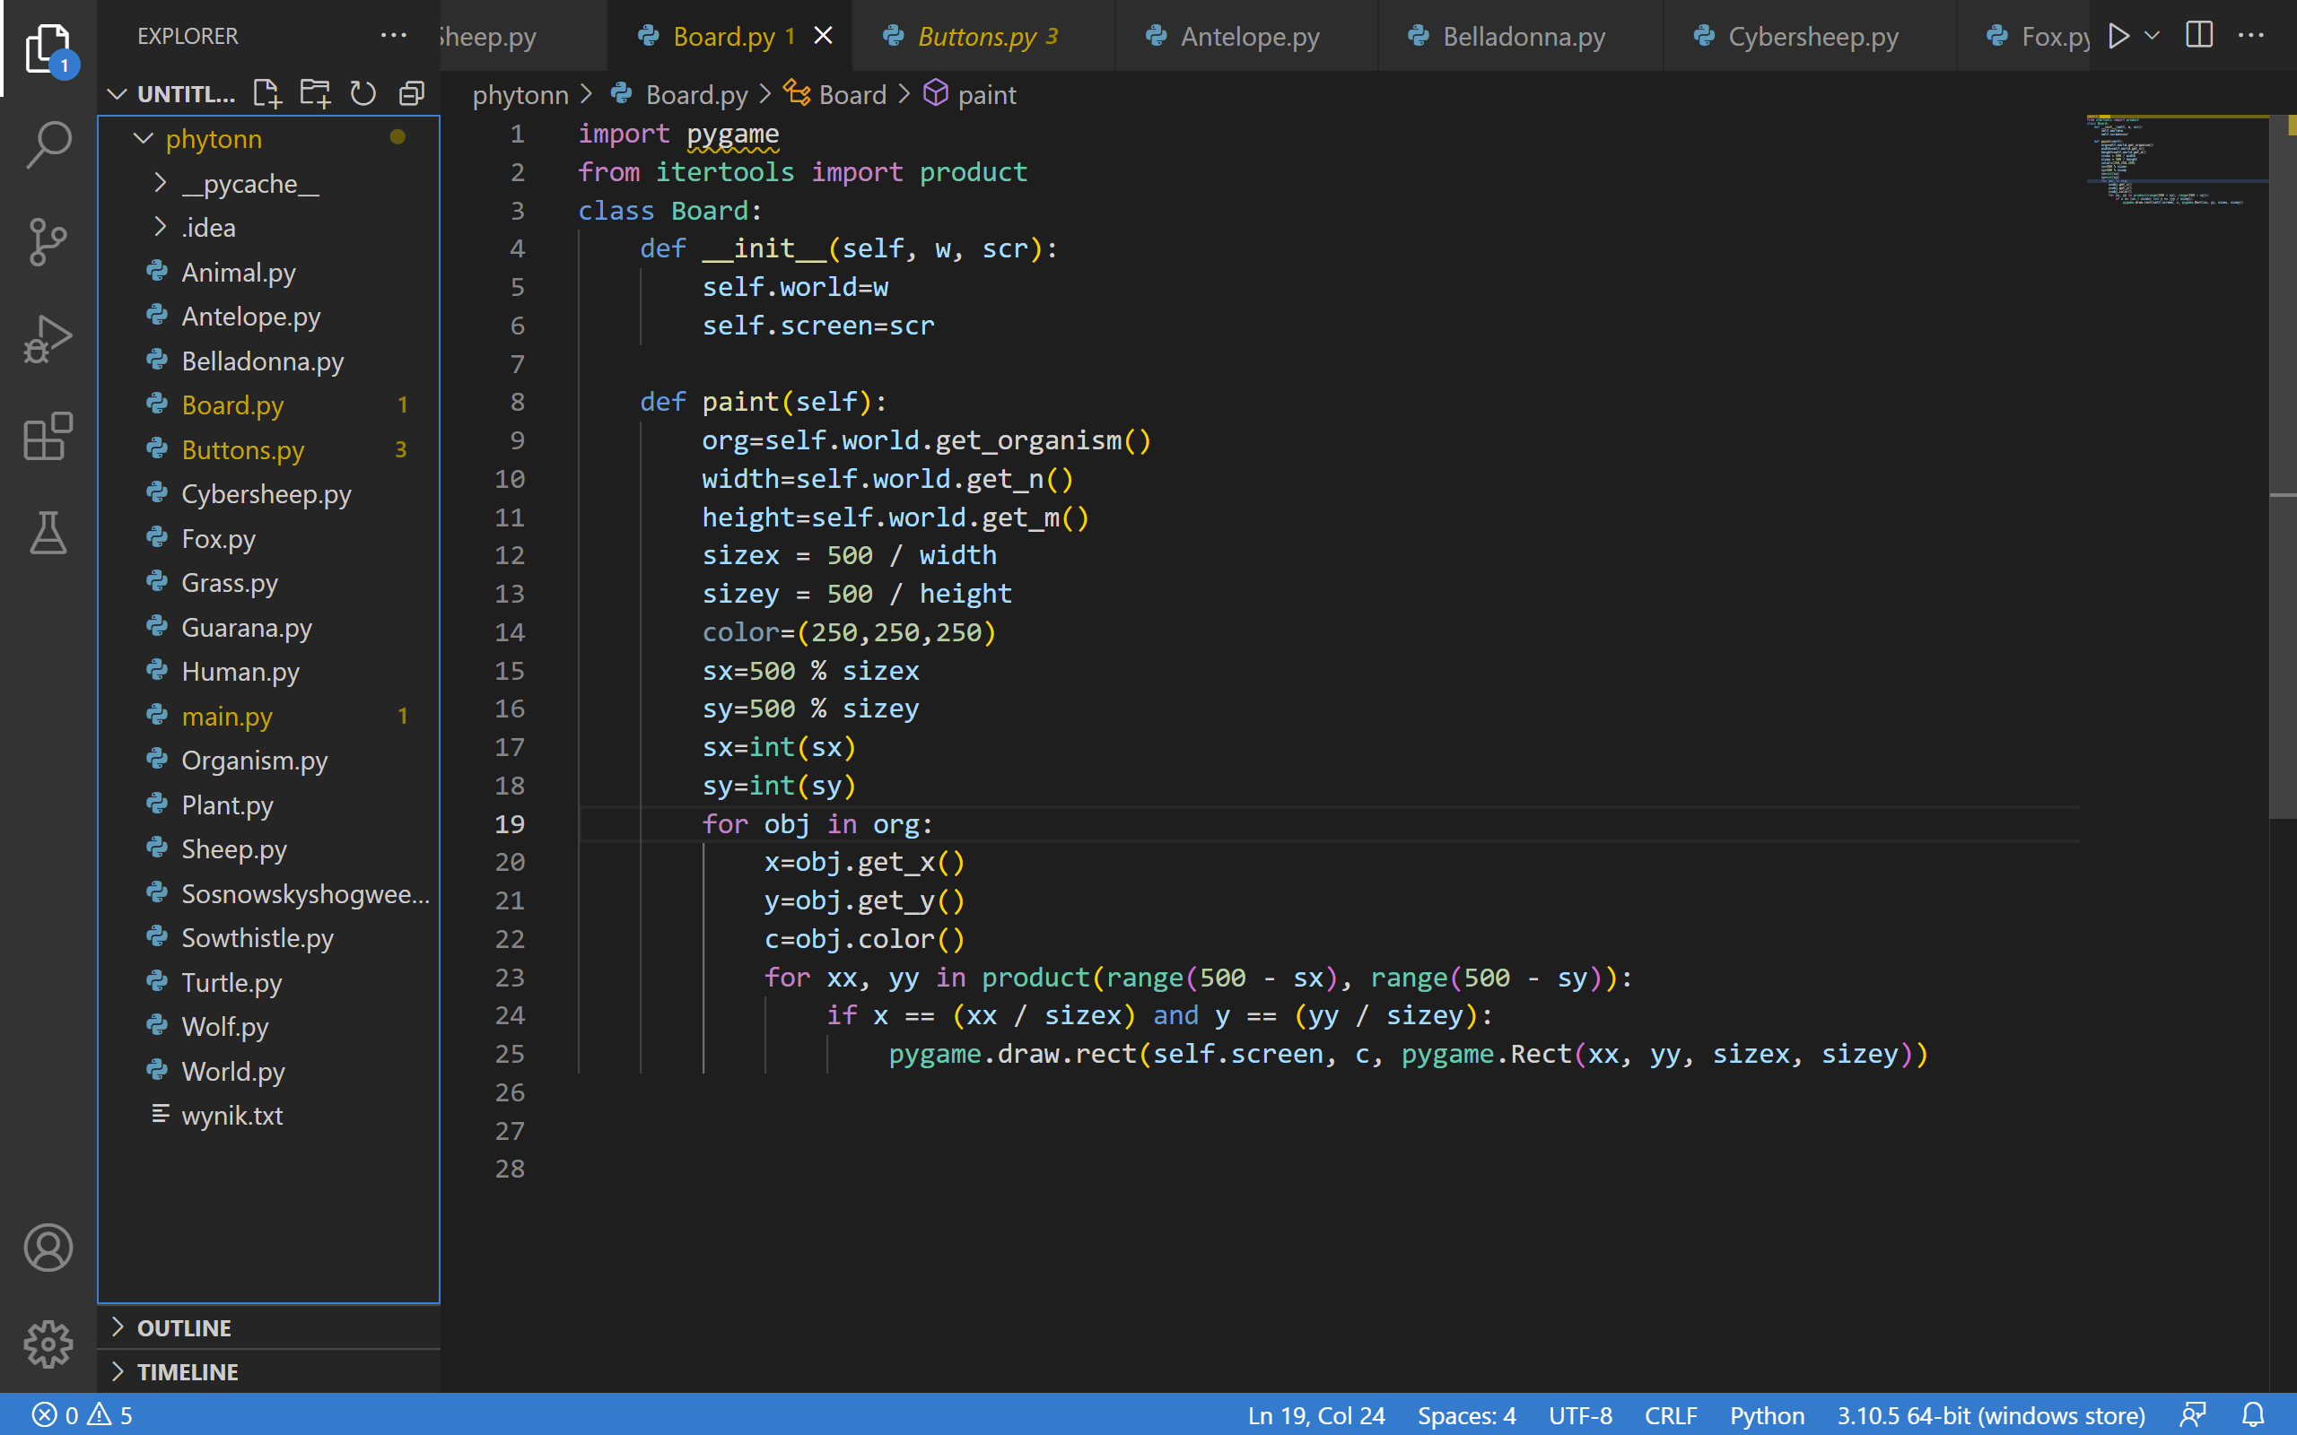

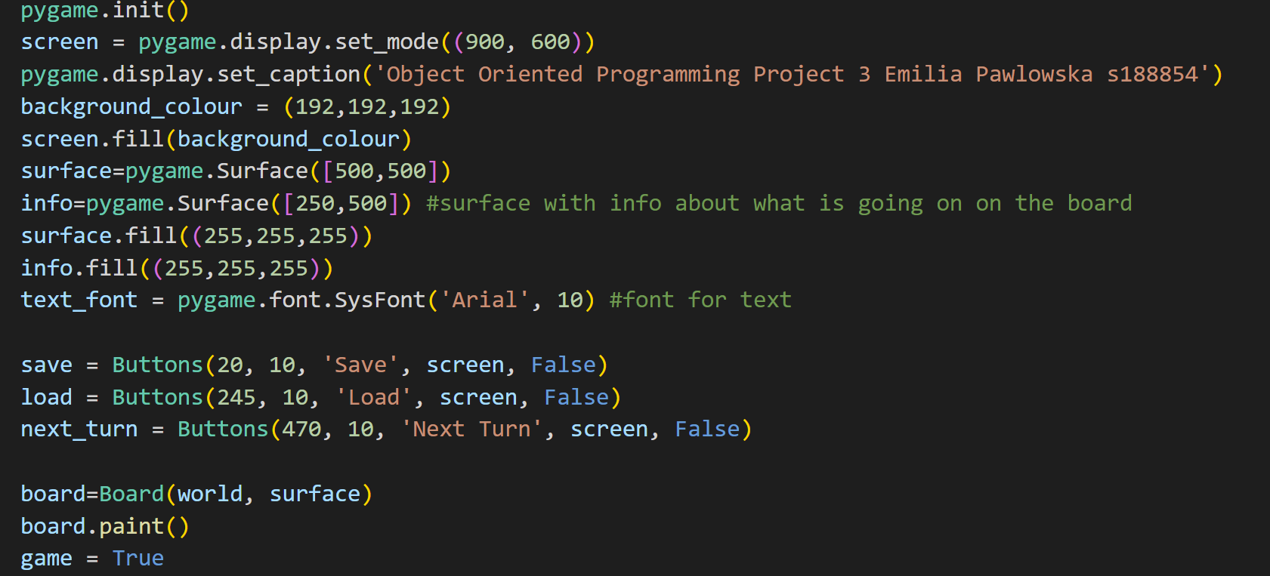

**Loading:**

